**Business Case: Car Pooling System**

**UML DIAGRAMS**

**Submitted By:**

**Sahil shah(16BEC0082)** [**sahil.shah208@gmail.com**](mailto:sahil.shah208@gmail.com)

**Ashish kolte(16BCE0744)**[**ashishkolte66@gmail.com**](mailto:ashishkolte66@gmail.com)

**Nidhi Mittal(16BCE0625)** [**nidhimittal226@gmail.com**](mailto:nidhimittal226@gmail.com)

1. **Use Case Diagram**

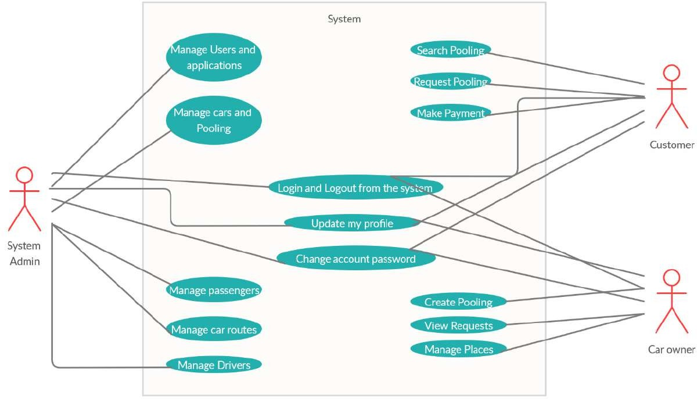

**2)Sequence Diagram:**

**Find A Ride**

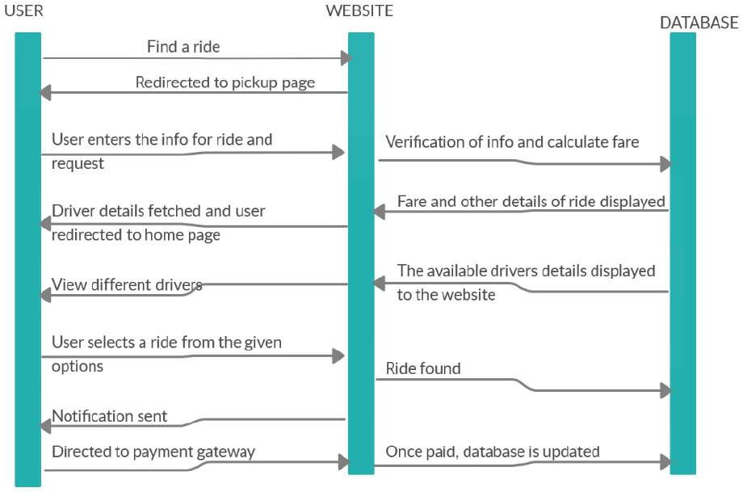

**Login/signup**

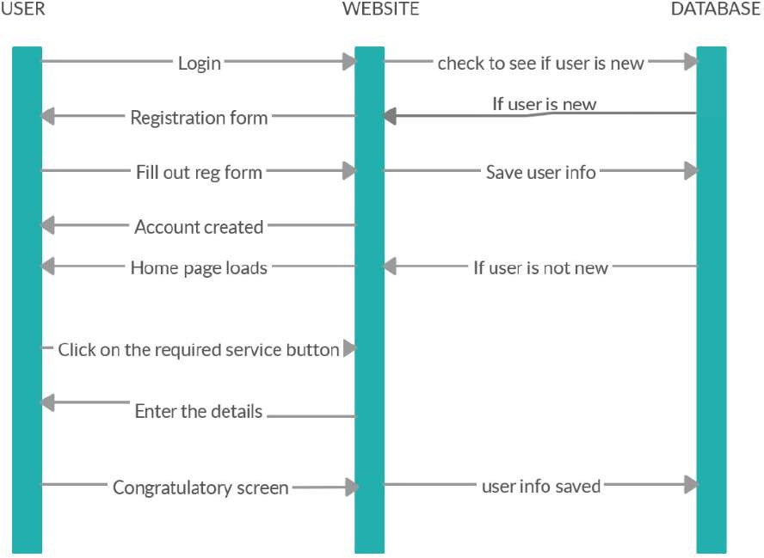

**Offer A Ride**

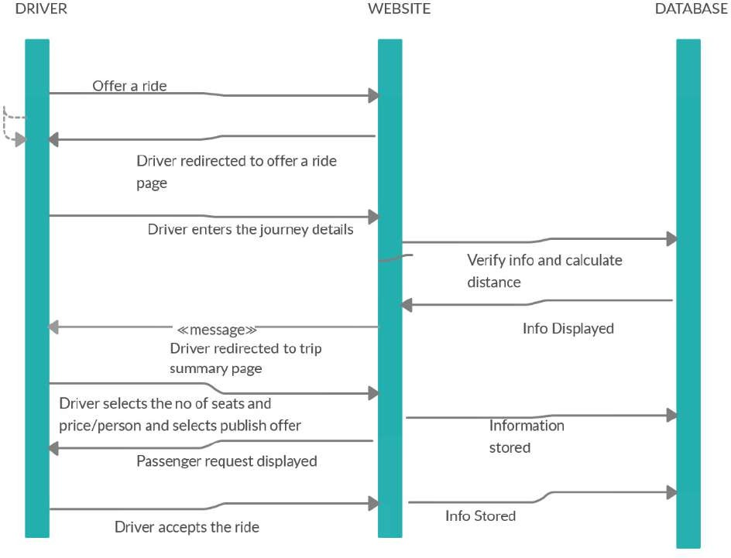

**3)Activity Diagram**

**Administration**

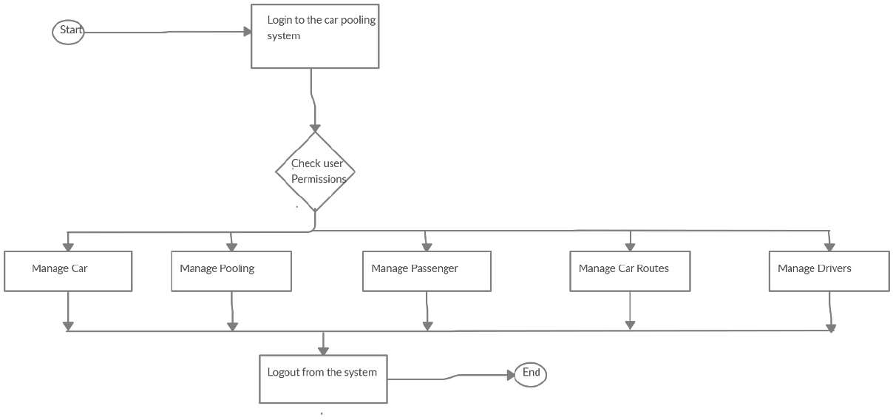

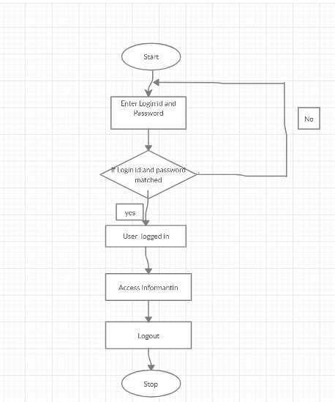 **Login/Signup**

**Offer A Ride**

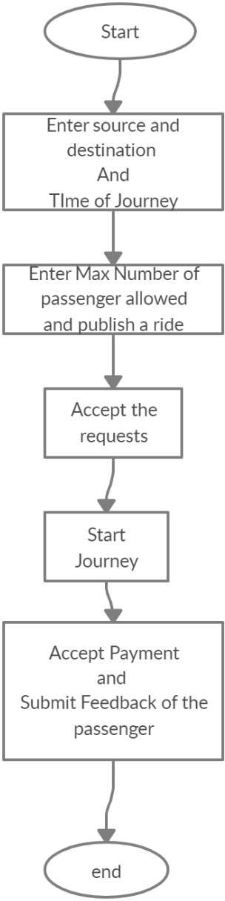

**Search A Ride**

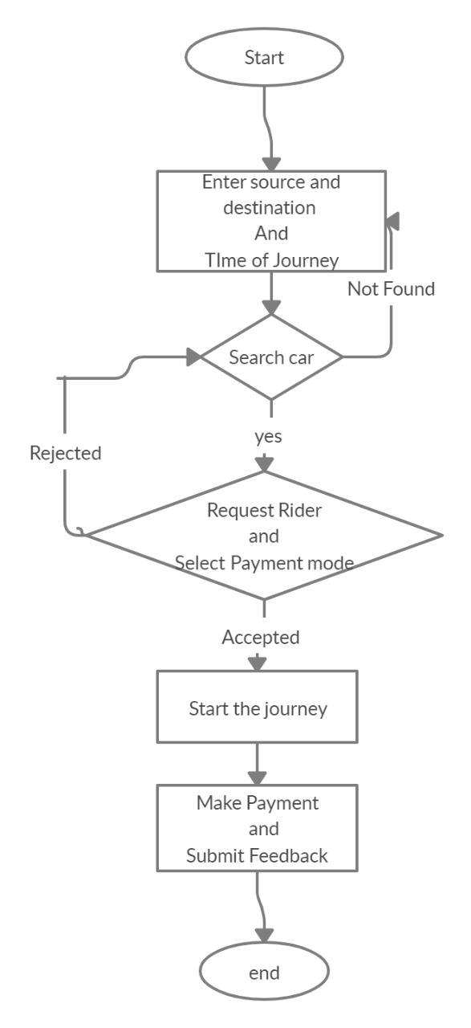

**4) Class Diagram**

